Triphala: Ayurveda’s Timeless Formula for Digestion, Detox, and Daily Wellness
Meta Description: Discover the power of Triphala — the ancient Ayurvedic blend of Amla, Haritaki, and Bibhitaki — for digestion, detox, and overall wellness. Learn benefits, dosage, and global sourcing from Indian herbal exporters.

🌿 Introduction: What Is Triphala?
Triphala, which literally means “three fruits,” is one of Ayurveda’s oldest and most powerful herbal blends. It combines the dried fruits of Amla (Emblica officinalis), Haritaki (Terminalia chebula), and Bibhitaki (Terminalia bellerica) — three potent botanicals revered for their cleansing, healing, and rejuvenating properties.
This Ayurvedic formula has been used for centuries to maintain digestive balance, detoxify the liver, and nourish the entire body. Unlike chemical laxatives, Triphala is gentle yet deeply effective, making it suitable for long-term wellness routines.
At [Your Company Name], we export premium-quality Triphala powder and capsules globally, sourced and processed under strict hygienic conditions in India — the heart of Ayurveda.

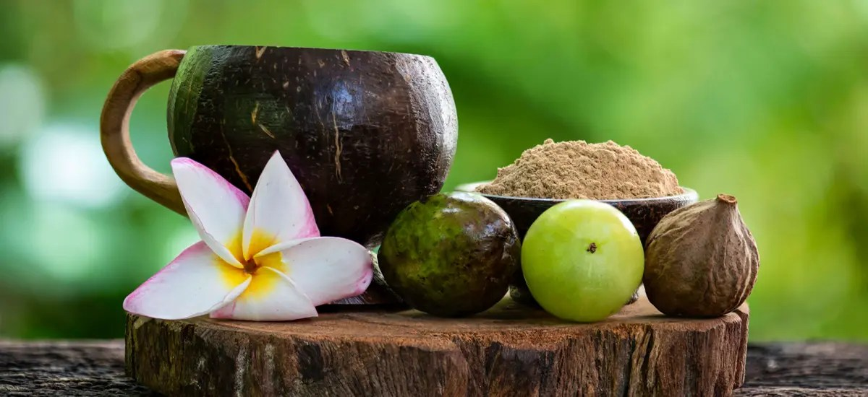
Caption: Pure Triphala powder — a balanced blend of three rejuvenating fruits from India’s Ayurvedic tradition.

🔬 Product and Technical Specifications
Parameter | Specification
Form | Powder
Active Assay | Tannins 30%
Shelf Life | 3 Years
Packaging Type | Loose or HDPE Drum
Is It Dried | Yes
Color | Brownish
Availability | In Stock
Country of Origin | India
Purity | 100% Natural
Composition (per 500 mg capsule):
- Terminalia chebula (Haritaki) Extract 166.66 mg
- Terminalia bellerica (Bibhitaki) Extract 166.66 mg
- Emblica officinalis (Amla) Extract 166.66 mg

⚗️ How Triphala Works: Ayurvedic Science Behind It
Triphala acts as a mild detoxifier and rejuvenator, balancing all three doshas — Vata, Pitta, and Kapha.
- Amla (Indian Gooseberry): Rich in Vitamin C and antioxidants, rejuvenates tissues and strengthens immunity.
- Haritaki: Known as the “King of Medicines” in Tibet, aids bowel movement, and supports liver function.
- Bibhitaki: Detoxifies the blood, reduces fat accumulation, and maintains respiratory health.
Together, they promote digestive harmony, support liver function, and help the body eliminate toxins naturally.

🩺 Key Health Benefits of Triphala

1. Supports Healthy Digestion
Triphala regulates bowel movement and relieves constipation, bloating, and indigestion without causing dependency. It maintains the natural rhythm of your gut microbiome.

2. Natural Detoxification
The formula cleanses the colon and liver, purifies the blood, and promotes toxin removal through natural elimination pathways.

3. Promotes Gut and Liver Health
Triphala stimulates bile flow, enhances liver function, and assists in processing fats and cholesterol.

4. Enhances Immunity
Thanks to its high Vitamin C and antioxidant content, Triphala helps boost immunity and combat oxidative stress.

5. Improves Vision and Eye Health
In Ayurveda, Triphala is known to rejuvenate the eyes — promoting clarity and reducing strain caused by modern screen exposure.

6. Cardiovascular and Cholesterol Support
It helps reduce LDL cholesterol, improve blood circulation, and regulate blood pressure levels.

7. Anti-Aging and Skin Benefits
Triphala combats free radicals and promotes collagen production, supporting youthful skin and healthy hair.

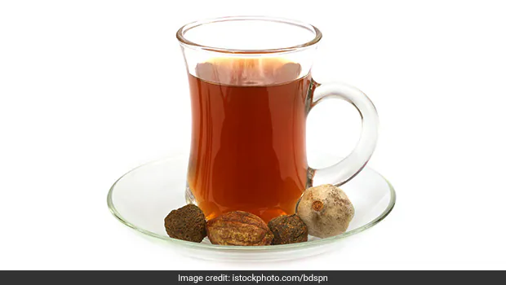
Caption: Triphala tea — a natural detox and digestive booster for daily wellness.

🧘‍♀️ Therapeutic Indications
Triphala is recommended for a wide range of conditions, including:
- Abdominal distention and bloating
- Constipation and gastric disorders
- Liver congestion and high cholesterol
- Weak eyesight and premature aging
- Bronchitis, asthma, and blood impurities
- Headache, cold, and lack of appetite
Contraindications: None known
Side Effects: None reported with recommended dosage

💊 Dosage & Usage
Capsules: 1 capsule once or twice daily after meals with lukewarm water.
Powder: ½ to 1 teaspoon mixed in warm water before bedtime or early morning.
Avoid: Alcohol, caffeine, and fizzy drinks during consumption for best results.

🍵 Recipes & Consumption Tips

1. Triphala Herbal Tea
Ingredients:
- 1 tsp Triphala powder
- 1 cup hot water
- ½ tsp honey (optional)
Instructions:
Steep the powder in hot water for 10 minutes. Strain and sip slowly to support digestion and detox.

2. Morning Cleansing Drink
Mix 1 tsp Triphala powder in a glass of warm water. Drink it first thing in the morning to cleanse the colon and promote energy flow.

3. Triphala Churna Smoothie
Add ½ tsp Triphala powder to your green smoothie for antioxidant and immune-boosting benefits.

4. Triphala Honey Tonic
Blend Triphala powder with honey and lemon juice. Take a spoonful daily for glowing skin and liver health.

🧪 Clinical Insights & Ayurvedic Validation
According to multiple Ayurvedic texts and modern studies:
- Triphala improves peristaltic movement (intestinal contraction).
- Its antioxidant capacity is comparable to Vitamin E.
- Regular intake enhances liver enzyme activity, aiding detoxification.
- It is found to have anti-inflammatory, antimicrobial, and adaptogenic effects.
Modern researchers have explored Triphala’s potential in managing diabetes, hyperlipidemia, and stress-induced conditions, confirming the wisdom of classical Ayurveda.

🏭 Why Choose Indian Exporters for Triphala?
India’s Ayurvedic tradition ensures authenticity and potency. As leading Triphala exporters from India, we offer:
- Standardized Tannins (30%) with quality validation.
- Loose or capsule form for bulk buyers.
- 3-year shelf life and global-grade packaging.
- FSSAI, ISO, and GMP-certified facilities.
- Bulk export packaging in HDPE drums with double poly bag protection.
- Private labeling and customized branding options.
Our herbal exports uphold purity, traceability, and efficacy — from raw sourcing to finished delivery.
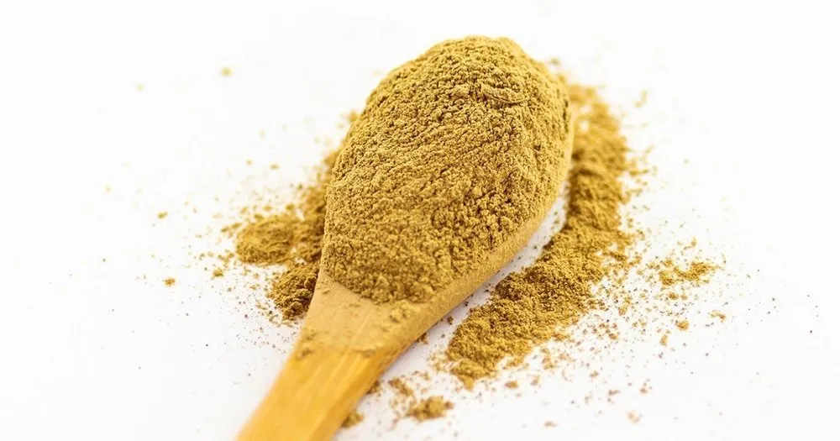
Caption: Triphala powder texture

🔗 Suggested Internal Links
- Explore More Herbal Extracts from India
- Shop Triphala Powder & Capsules
- Learn About Ayurvedic Detox Herbs
- Our Global Certifications
- Contact for Bulk Orders

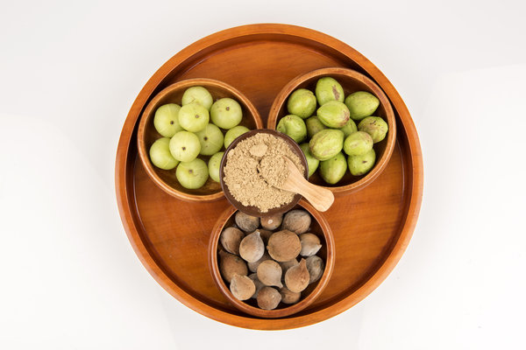

🌏 Conclusion: The Ancient Secret to Modern Wellness
Triphala is more than just an herbal supplement — it’s a complete body rejuvenator. From promoting digestion and liver health to purifying blood and boosting immunity, this three-fruit formula embodies the holistic wisdom of Ayurveda.
As a trusted Triphala exporter from India, we deliver authentic, high-quality products that meet international safety and potency standards. Add Triphala to your product portfolio or daily wellness routine — and experience the harmony of ancient tradition and modern science.

Keywords: Herbal export India, Triphala exporter, Triphala powder, Ayurvedic supplements export, herbal digestion formula, detox herbs India.

